
AGENTS NOTICE:
If your county misses the July 1 deadline to certify your county registration and your volunteer worker for state fair, you will NOT be allowed to participate in the Country Ham Project in 2027.
Deadline to Register: December 10th 2025

2026 Kentucky 4-H Country Ham Project
NAME

ADDRESS

TELEPHONE COUNTY

BIRTHDATE GRADE

Please read each and initial you understand the requirements of the project:
By taking part in the country ham project, I am responsible for the following: | 4-H  Member initial | Parent/ Guardian Initial
Must complete 6 hours of training under the supervision of a certified livestock volunteer.
Giving a 3-5-minute presentation at KY State Fair on the required topic:
Junior (Born 2016-2012) The difference between wet and dry cured hams. Grocery stores throughout the Southeast sell wet and dry cured hams. Discuss the differences between wet cured (aka City Ham) and dry cured (aka Country Ham), include differences in how they are made, flavor differences, and how they are stored.
Senior (Born 2007-2011) The science of curing and aging country hams. Discuss the science of curing and aging country hams, including the purpose of salt, sugar, and nitrite; what happens during aging aka the summer sweat, and why country hams do not need refrigeration.
Please note – ALL SENIOR’S PRESENTATIONS MUST BE AT LEAST 2 MINUTES LONG OR THEY WILL BE DIS-QUALIFIED AND HAMS FORFIETED.
Pay $75.00 fee – you will receive 2 hams – Hams are to remain at County Designated facility until state fair– Will NOT be allowed to be individuals homes/facilities.
(failure to complete the project, fee will NOT be refunded, and you will forfeit both hams, Upon forfeit, if the two hams are not returned an additional $75.00 fee will be charged and if the additional fee is not paid the 4-H member will not be able to participate in next years’ country ham project).
All winning hams will be placed on display at the Kentucky State Fair and at its conclusion will be returned.
Completion of the 4-H Country Ham project makes 4-Her eligible to apply for Country Ham Scholarship, applications are due July 2026.

Parents Signature Date

4-H’er Signature Date

Agent Signature Date
Agents please scan this document into 4-H Online when you sign up youth.
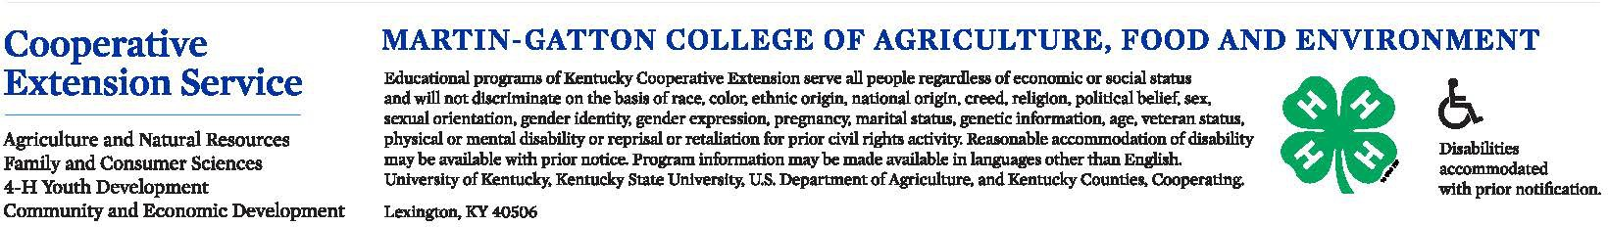


Fleming County
4-H Youth Development

4-H Country Ham Project COMMITMENT FORM
I accept the invitation to participate in the 4-H Country Ham Project of 2025-2026.

I understand that in order to receive the full benefit of this program, I MUST meet all requirements:

Parent Initials | Dates | Topic | Location | Time
 |  | 4-H Enrollment for 2025-2026 – This must be completed annually. Scan the QR Code or request a paper copy from the Extension office |  | Due with application
 | January 8th | 4-H Country Ham Curing Prep Meeting w/ Dr. Rentfrow  -Recommended to have a parent attend with first time participants | Extension Office | 6:00pm-7:30pm
 | January 19th | 4-H Country Ham Curing | Extension Office | 4:00-7:00 pm
 | March 17th | 4-H Country Ham Speech Writing Workshop – Bring Laptop or Chromebook (if available) | Extension Office | Afterschool until 6:30pm  (Only need to come and stay for 1 hour)
 | May 1st | 4-H Country Ham Speech Draft Due – Share via email with staci.newsom@uky.edu or submit a hard copy draft (Do not share via google drive) | Electronic Submission | 8:30am-5:00pm
 | May 4th | 4-H Country Ham Cleaning – Bring Tub | Extension Office | Afterschool – 7:00pm
 | August 18th | 4-H Country Ham Cleaning  -Bring Tub, scrub brush, trimming tools as needed | Extension Office | 10am – 6:30pm (Come anytime)
 | August 20th | Kentucky State Fair 4-H Country Ham Day  -You are required for your own transportation to and from the Kentucky State Fair | Louisville, KY | All Day
 | November 5th  (tentative) | 4-H Country Ham Auction – SAVE THE DATE  *4-Her MUST be present to sell their country ham  *If 4-Her gets DQ’d from KSF they are DQ from the Ham Auction | TBD | 5:30 pm

Parent/Guardian Signature Date

PO Box 192 | Flemingsburg, KY 41041-0192 | P: 606-845-4641 | staci.newsom@uky.edu | fleming.ca.uky.edu
